1. Graph:

Using matplotlib.pyplot(for graph ploting)

Using numpy (numpy used for generating numbers )

1. Scatter
2. Plot
3. Bar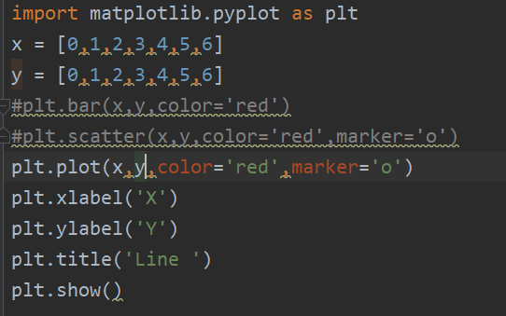
4. Pie

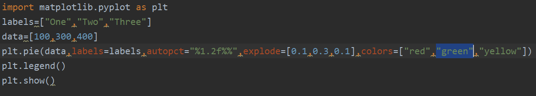

1. 3d graph plotting

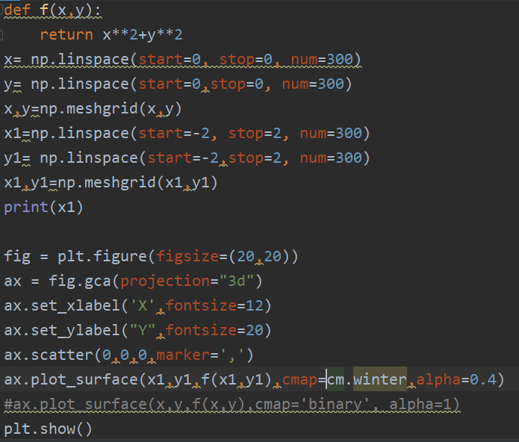

Data from Excel

Using Pandas

